Intermediate Algebra Lecture 7.1: Defining and Simplifying Rational Expressions
Rational function
A fraction where both the numerator and denominator are polynomials

Example of a rational expression
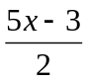

Example of a rational function

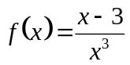
What you cannot do with a fraction.
You cannot divide by ZERO...

NOTE:
For any rational function the denominator cannot be zero.
BUT, if the denominator is zero at some point, then the function is undefined at that point.

Example
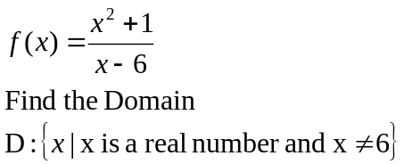

To find domain set denominator not equal to zeros and solve.

Example
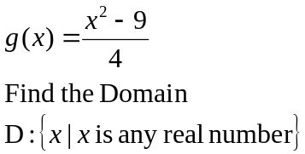

Example
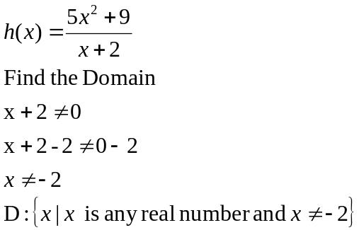

Example
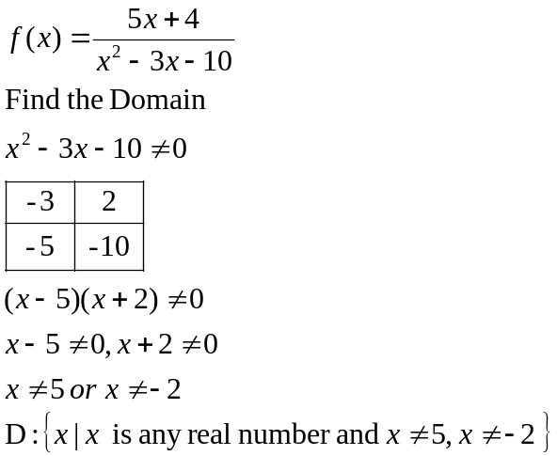

Simplify
When the numerator and denominator have common factors the rational expression can be simplified.

Example
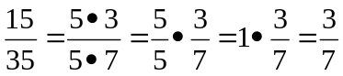

STEPS
- Factor both numerator and denominator completely
- Simplify common factors (NOT COMMON TERMS)

Example
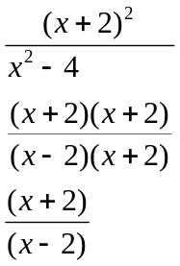

Example
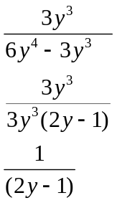

Example
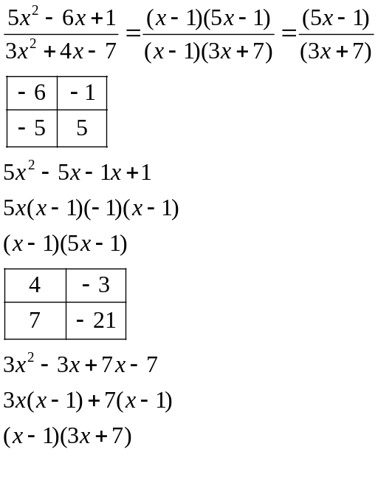
Example
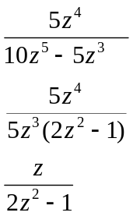

Example
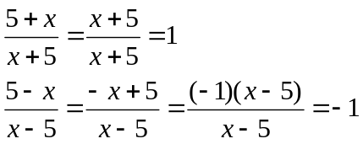

NOTE FACTOR TO Make the term with largest exponent is positive

Example
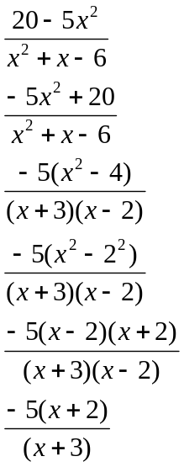

Example
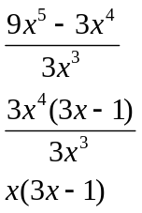

Example
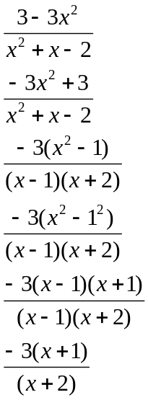

Example
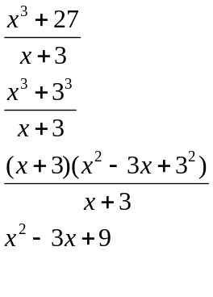

Example
